HeatMap
2026-04-28
library(DBI)
con <- dbConnect(RSQLite::SQLite(), dbname="D:/R/test/DB/P_BBS.db")
list_Point<-
dbReadTable(con, "list_Point") %>%
arrange(樣區編號, 獼猴樣區編號,as.numeric(樣點代號))
list_Site<-
dbReadTable(con, "list_Site")
table_point<-
dbReadTable(con, "table_point")
dbDisconnect(con)
list_Point_sf <-
list_Point %>%
filter(!is.na(X_97)) %>%
select(樣區編號, 獼猴樣區編號,樣點代號, X_97, Y_97)

BBS

林業署

合併及擷取2021-2024
source("D:/R/test/Macaca-population-trend/script/Analysis 2025 for Forestry/熱點圖/environment.R")
## Warning: package 'tibble' was built under R version 4.4.3
## ── Attaching core tidyverse packages ──────────────────────── tidyverse 2.0.0 ──
## ✔ forcats 1.0.0 ✔ readr 2.1.5
## ✔ purrr 1.0.4 ✔ tibble 3.3.0
## ── Conflicts ────────────────────────────────────────── tidyverse_conflicts() ──
## ✖ gridExtra::combine() masks dplyr::combine()
## ✖ lubridate::duration() masks arrow::duration()
## ✖ tidyr::extract() masks terra::extract()
## ✖ dplyr::filter() masks stats::filter()
## ✖ dplyr::lag() masks stats::lag()
## ℹ Use the conflicted package (<http://conflicted.r-lib.org/>) to force all conflicts to become errors
## Warning: package 'fs' was built under R version 4.4.3
## Reading layer `G1km_TWD97-121_Climate_2010s_variables' from data source
## `D:\R\SHP圖層\Taiwan_environmental_dataset-master\Shapefile\G1km_TWD97-121_Climate_2010s_variables\G1km_TWD97-121_Climate_2010s_variables.shp'
## using driver `ESRI Shapefile'
## Simple feature collection with 40254 features and 82 fields
## Geometry type: POLYGON
## Dimension: XY
## Bounding box: xmin: 143000 ymin: 2420000 xmax: 364000 ymax: 2839000
## Projected CRS: Transverse_Mercator
## Reading layer `G1km_TWD97-121_DTM_variables' from data source
## `D:\R\SHP圖層\Taiwan_environmental_dataset-master\Shapefile\G1km_TWD97-121_DTM_variables\G1km_TWD97-121_DTM_variables.shp'
## using driver `ESRI Shapefile'
## Simple feature collection with 40254 features and 11 fields
## Geometry type: POLYGON
## Dimension: XY
## Bounding box: xmin: 143000 ymin: 2420000 xmax: 364000 ymax: 2839000
## Projected CRS: Transverse_Mercator
## Reading layer `G1km_TWD97-121_Landuse_2010s_variables' from data source
## `D:\R\SHP圖層\Taiwan_environmental_dataset-master\Shapefile\G1km_TWD97-121_Landuse_2010s_variables\G1km_TWD97-121_Landuse_2010s_variables.shp'
## using driver `ESRI Shapefile'
## Simple feature collection with 40254 features and 12 fields
## Geometry type: POLYGON
## Dimension: XY
## Bounding box: xmin: 143000 ymin: 2420000 xmax: 364000 ymax: 2839000
## Projected CRS: Transverse_Mercator
## Reading layer `G1km_TWD97-121_Other_variables' from data source
## `D:\R\SHP圖層\Taiwan_environmental_dataset-master\Shapefile\G1km_TWD97-121_Other_variables\G1km_TWD97-121_Other_variables.shp'
## using driver `ESRI Shapefile'
## Simple feature collection with 40254 features and 7 fields
## Geometry type: POLYGON
## Dimension: XY
## Bounding box: xmin: 143000 ymin: 2420000 xmax: 364000 ymax: 2839000
## Projected CRS: Transverse_Mercator
combine_bb <-
M.data_F %>%
bind_rows(
##移除有匯入BBS的林保署鳥類樣區
M.data%>%
anti_join(M.data_F[, c('獼猴樣區編號', "樣區編號",'Year')],
by = c('獼猴樣區編號', "樣區編號",'Year'))
) %>%
filter(Year %in% c(2021:2024)) %>%
st_as_sf(coords = c("X_97", "Y_97"), crs = 3826) %>%
st_join(environment_sf) %>%
st_drop_geometry() %>%
select(-c(`Bio02`:`Bio11`, `Bio13`:`Bio19`),
-starts_with('Tmax'),
-starts_with('Tmin'),
-starts_with('Tra')
)
observations <- combine_bb |>
filter(Macaca_sur == 1 & Macaca_dist %in% c('A', 'B')) %>%
# add a binary variable for detection
mutate(species_observed = TRUE)
#observations and "zero-fill"
zf <-
left_join(combine_bb, observations) |>
mutate(species_observed = coalesce(species_observed, FALSE) ,
observation_count = ifelse(species_observed, 1, 0))
## Joining with `by = join_by(樣區編號, 獼猴樣區編號, 樣點代號, Year, Month, Day,
## Survey, Hour, Minute, Macaca_sur, Macaca_dist, day_of_year, GRIDID, x, y,
## Temp01, Temp02, Temp03, Temp04, Temp05, Temp06, Temp07, Temp08, Temp09, Temp10,
## Temp11, Temp12, Prec01, Prec02, Prec03, Prec04, Prec05, Prec06, Prec07, Prec08,
## Prec09, Prec10, Prec11, Prec12, Bio01, Bio12, ELE, ELEMAX, ELEMIN, ELERA,
## ELESD, Slope, Aspect, ASR, FF, MD, FW, FO, WL, UB, WB, BU, BL, LROAD, PROAD,
## DFW, DSW)`
sum(zf$species_observed)
## [1] 1027
# ├ 應用努力量過濾 / Apply effort filters ----
# 其實我前面已經filter過資料了
zf_filtered <- zf
# 將清單按 20/80 比例分割為測試集與訓練集 / split checklists into 20/80 test/train
zf_filtered $type <- if_else(runif(nrow(zf_filtered )) <= 0.8, "train", "test")
table(zf_filtered $type) / nrow(zf_filtered )
##
## test train
## 0.1993367 0.8006633
# ├ 觀測分佈圖 / Observations map ----
# 用於背景的國家邊界 / country boundaries for context
countries <- ne_countries(scale = 10, continent = "Asia") |>
select(name)
checklists_sf <- zf_filtered |>
# 轉換為空間點 / convert to spatial points
st_as_sf(coords = c("x", "y"), crs = 3826) |>
select(species_observed) %>%
st_transform(crs = 4326)
# 繪圖 / map
par(mar = c(0.25, 0.25, 0.25, 0.25))
# 設置繪圖區域 / set up plot area
plot(st_geometry(checklists_sf),
col = NA, border = NA)
# 國家邊界 / country boundaries
plot(countries, col = "#cfcfcf", border = "#888888", lwd = 0.5, add = TRUE)
# eBird 觀測點 / ebird observations
# 未觀測到 / not observed
plot(filter(checklists_sf, !species_observed),
pch = 19, cex = 0.05, col = alpha("#555555", 0.1),
add = TRUE)
# 有觀測到 / observed
plot(filter(checklists_sf, species_observed),
pch = 19, cex = 0.15, col = alpha("#4daf4a", 0.5),
add = TRUE)
# 圖例 / legend
legend("topleft", bty = "n",
col = c("#555555", "#4daf4a"),
legend = c("Macaca_check", "Detections"),
pch = 19)
box()
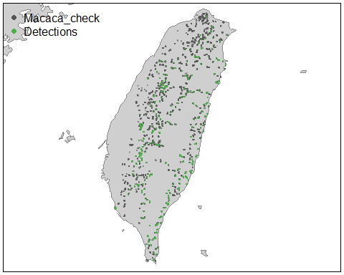
# ├ 時空子抽樣 / Spatiotemporal subsampling ----
# 每年每個 1km x 1km x 1周的網格抽樣一份清單 / sample one checklist per 1 km x 1 km x 1 week grid for each year
# 獨立抽樣偵測與未偵測數據 / sample detection/non-detection independently
# 按類型（測試/訓練）分層 / stratify by type (test/train)
zf_filtered <-
zf_filtered %>%
bind_cols(
zf_filtered %>%
st_as_sf(coords = c("x", "y"), crs = 3826) %>%
st_transform(crs = 4326) %>%
st_coordinates(zf_filtered) %>%
as.data.frame() %>%
setNames(., c("longitude", "latitude")) %>%
st_drop_geometry()
) %>%
mutate(year = Year)
checklists_ss <- grid_sample_stratified(zf_filtered,
res = c(1000, 1000, 7),
obs_column = "species_observed",
by_year = TRUE,
case_control = TRUE,
sample_by = "type")
# explore impact of sampling
# original data
nrow(zf_filtered)
## [1] 29849
count(zf_filtered, species_observed) |>
mutate(percent = n / sum(n))
## species_observed n percent
## 1 FALSE 28822 0.96559349
## 2 TRUE 1027 0.03440651
# after sampling
nrow(checklists_ss)
## [1] 12692
count(checklists_ss, species_observed) |>
mutate(percent = n / sum(n))
## species_observed n percent
## 1 FALSE 11968 0.94295619
## 2 TRUE 724 0.05704381
# pred_grid <- read_parquet("D:/待處理工作夾(做完要歸檔)/ebird-workshop_taiwan-2025/data/prediction-grid_1km_tw.parquet")
pred_grid <- environment_sf %>%
st_drop_geometry() %>%
as_tibble() %>%
# 2. 補足模型預測所需的標準化變數
# 這裡設定的值是為了讓全島的預測結果是在相同的「努力量」基準下比較
mutate(
year = 2024,
day_of_year = 136, # 代表 5 月 15 日
solar_noon_diff = 0, # 設定在正午
effort_distance_km = 1, # 標準化：步行 1 公里
effort_hours = 1, # 標準化：費時 1 小時
effort_speed_kmph = 1, # 標準化：時速 1 公里
number_observers = 1 # 標準化：1 位觀察者
)
# load the raster template for the grid
r <- rast("D:/待處理工作夾(做完要歸檔)/ebird-workshop_taiwan-2025/data/prediction-grid_1km_tw.tif") |>
rast()
elevation <- pred_grid |>
# convert to spatial features
st_as_sf(coords = c("x", "y"), crs = 3826) %>%
st_transform(crs = crs(r)) |>
# rasterize points
rasterize(r, field = "ELE")
# make a map of elevation
plot(elevation,
axes = FALSE, box = FALSE, col = viridis(10),
main = "Elevation [m]")
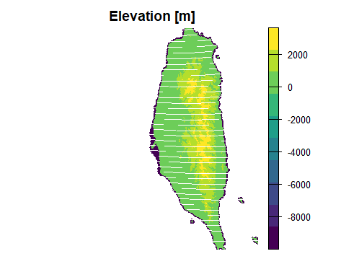
# Relative abundance model ----
# filter to training data, select only the columns to be used in the model
checklists_train <- checklists_ss |>
filter(type == "train") |>
select(species_observed, observation_count,
year, day_of_year,
`Temp01`:`DSW`
)
# calculate detection frequency
detection_freq <- mean(checklists_train$species_observed)
n_detections <- sum(checklists_train$species_observed)
# ├ Range ----
# train a balanced binary classification forest for range boundary
# remove observation_count prior to training model
train_er <- select(checklists_train, -observation_count)
train_er$species_observed <- factor(train_er$species_observed)
rf_range <- ranger(
formula = species_observed ~ .,
data = train_er,
importance = "impurity",
sample.fraction = c(detection_freq, detection_freq)
)
# ├ Encounter rate ----
# train a balanced probability forest for encounter rate
rf_er <- ranger(
formula = species_observed ~ .,
data = train_er,
importance = "impurity",
probability = TRUE,
sample.fraction = c(detection_freq, detection_freq),
min.node.size = ceiling(n_detections * 0.02)
)
# ├ Calibration ----
# predicted encounter rate based on out of bag samples
er_pred <- rf_er$predictions[, "TRUE"]
# observed detection, converted back from factor
det_obs <- as.integer(checklists_train$species_observed == "TRUE")
# construct a data frame to train the scam model
obs_pred <- data.frame(obs = det_obs, pred = er_pred)
# train calibration model
calibration_model <- scam(obs ~ s(pred, k = 6, bs = "mpi"),
gamma = 2,
data = obs_pred)
# 校準圖 / calibration plot
# 將預測的遭遇率以 0.02 為間隔分組，計算每組的平均觀測率 / group predicted rate into bins, calculate mean obs rate
er_breaks <- seq(0, 1, by = 0.02)
mean_er <- obs_pred |>
mutate(er_bin = cut(pred, breaks = er_breaks, include.lowest = TRUE)) |>
group_by(er_bin) |>
summarise(n_checklists = n(),
pred = mean(pred),
obs = mean(obs),
.groups = "drop")
# 使用校準模型進行預測 / make predictions from the calibration model
calibration_curve <- data.frame(pred = er_breaks)
cal_pred <- predict(calibration_model, calibration_curve, type = "response")
calibration_curve$calibrated <- cal_pred
# 比較分組平均遭遇率與校準模型 / compared binned mean encounter rates to calibration model
ggplot(calibration_curve) +
aes(x = pred, y = calibrated) +
geom_abline(slope = 1, intercept = 0, linetype = "dashed") +
geom_line(color = "blue") +
geom_point(data = mean_er,
aes(x = pred, y = obs),
size = 2, alpha = 0.6,
show.legend = FALSE) +
labs(x = "Estimated encounter rate",
y = "Observed encounter rate",
title = "Calibration model") +
coord_equal(xlim = c(0, 1), ylim = c(0, 1))
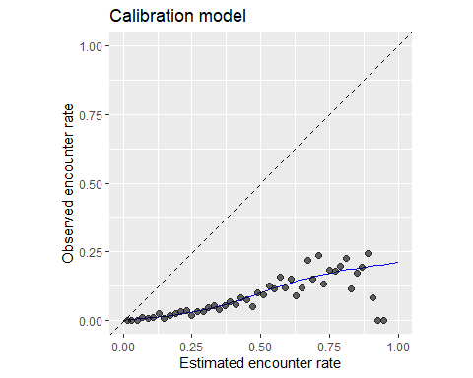
# ├ 數量模型 / Count ----
# 障礙模型：僅篩選出偵測到的數據用於數量模型 / hurdle: subset to detections only for the count model
train_count <- checklists_train |>
filter(!is.na(observation_count), species_observed) |>
select(-species_observed)
# 插件法：將預測的遭遇率作為額外的協變量添加 / plugin: add predicted encounter rate as additional covariate
predicted_er <- predict(rf_er, data = train_count, type = "response")
predicted_er <- predicted_er$predictions[, "TRUE"]
train_count$predicted_er <- predicted_er
# 訓練用於數量的回歸森林 / train a regression forest for count
rf_count <- ranger(
formula = observation_count ~ .,
data = train_count,
importance = "impurity"
)
# 預測 / Prediction ----
# 將標準化的努力量協變量添加到預測網格 / add standardized effort covariates to prediction grid
# 2024-05-15 正午前 5 小時，2公里1小時的單人觀測清單
# 2024-05-15 at 5 hours before solar noon, 2 km, 1 hour traveling checklist with 1 observer
pred_grid_eff <- pred_grid |>
mutate(observation_date = ymd("2024-03-01"),
year = year(observation_date),
day_of_year = yday(observation_date),
#solar_noon_diff = -5,
# effort_distance_km = 2,
# effort_hours = 1,
# effort_speed_kmph = 2,
number_observers = 1)
# 估計分佈範圍 / estimate range
pred_range <- predict(rf_range, data = pred_grid_eff, type = "response")
pred_range <- as.integer(pred_range$predictions == "TRUE")
# 估計遭遇率 / estimate encounter rate
pred_er <- predict(rf_er, data = pred_grid_eff, type = "response")
pred_er <- pred_er$predictions[, "TRUE"]
# 應用校準 / apply calibration
pred_er_cal <- predict(calibration_model,
data.frame(pred = pred_er),
type = "response") |>
as.numeric()
# 限制在 0-1 之間 / constrain to 0-1
pred_er_cal[pred_er_cal < 0] <- 0
pred_er_cal[pred_er_cal > 1] <- 1
# 估計數量 / estimate count
pred_grid_eff$predicted_er <- pred_er
pred_count <- predict(rf_count, data = pred_grid_eff, type = "response")
pred_count <- pred_count$predictions
# 將預測結果與單元 ID 及坐標合併 / combine predictions with cell id and coordinates
predictions <- data.frame(cell_id = pred_grid_eff$GRIDID,
x = pred_grid_eff$x,
y = pred_grid_eff$y,
range = pred_range,
encounter_rate = pred_er_cal,
count = pred_count,
abundance = pred_range * pred_er_cal * pred_count
)
# ├ 預測結果柵格化 / Rasterize predictions ----
# 將預測結果插入柵格模板 / insert predictions into the raster template
r_pred <- predictions |>
# 轉換為空間特徵 / convert to spatial features
st_as_sf(coords = c("x", "y"), crs = 3826) %>%
st_transform(crs = st_crs(r)) |>
# 柵格化 / rasterize
rasterize(r, field = c("range",
"encounter_rate",
"count",
"abundance" ))
# ├ 預測地圖 / Prediction maps ----
countries_proj <- st_transform(countries, st_crs(r))
tw_boundary <- filter(countries_proj, name == "Taiwan") |>
st_geometry()
# 繪製遭遇率地圖 / map encounter rate
par(mar = c(4, 0.25, 0.25, 0.25))
plot(tw_boundary, col = NA, border = NA)
plot(countries_proj, col = "#cfcfcf", border = "#888888", lwd = 0.5,
add = TRUE)
# 定義分位數斷點，排除零值 / define quantile breaks, excluding zeros
brks <- ifel(r_pred[["encounter_rate"]] > 0, r_pred[["encounter_rate"]], NA) |>
global(fun = quantile,
probs = seq(0, 0.1, 0.001), na.rm = TRUE) |>
as.numeric() |>
unique()
# 標註最小值、中位數與最大值 / label the bottom, middle, and top value
lbls <- round(c(min(brks), median(brks), max(brks)), 3)
# eBird 狀態與趨勢調色板 / ebird status and trends color palette
pal <- ebirdst_palettes(length(brks) - 1)
plot(r_pred[["encounter_rate"]],
col = c("#e6e6e6", pal), breaks = c(0, brks),
maxpixels = ncell(r_pred),
legend = FALSE, axes = FALSE, bty = "n",
add = TRUE)
box()
# 圖例 / legend
par(new = TRUE, mar = c(0, 0, 0, 0))
title <- glue("encounter rate (May 2024)")
image.plot(zlim = c(0, 1), legend.only = TRUE,
col = pal, breaks = seq(0, 1, length.out = length(brks)),
smallplot = c(0.15, 0.85, 0.05, 0.08),
horizontal = TRUE,
axis.args = list(at = c(0, 0.5, 1), labels = lbls,
fg = "black", col.axis = "black",
cex.axis = 0.75, lwd.ticks = 0.5,
padj = -1.5),
legend.args = list(text = title,
side = 3, col = "black",
cex = 1, line = 0.1))
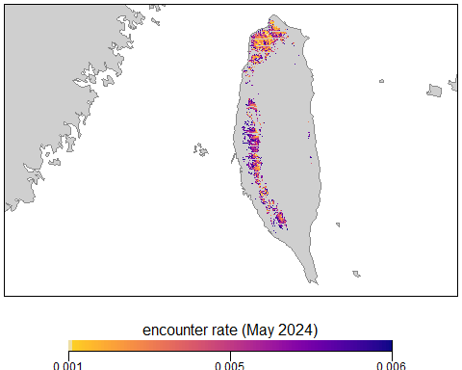
# 繪製範圍內的相對豐度圖 / map relative abundance in range
par(mar = c(4, 0.25, 0.25, 0.25))
plot(tw_boundary, col = NA, border = NA)
plot(countries_proj, col = "#cfcfcf", border = "#888888", lwd = 0.5, add = TRUE)
# 定義分位數斷點，排除零值 / define quantile breaks, excluding zeros
brks <- ifel(r_pred[["abundance"]] > 0, r_pred[["abundance"]], NA) |>
global(fun = quantile,
probs = seq(0, 1, 0.1), na.rm = TRUE) |>
as.numeric() |>
unique()
lbls <- round(c(min(brks), median(brks), max(brks)), 2)
pal <- ebirdst_palettes(length(brks) - 1)
plot(r_pred[["abundance"]],
col = c("#e6e6e6", pal), breaks = c(0, brks),
maxpixels = ncell(r_pred),
legend = FALSE, axes = FALSE, bty = "n",
add = TRUE)
box()
# 圖例 / legend
par(new = TRUE, mar = c(0, 0, 0, 0))
title <- glue("relative abundance (May 2024)")
image.plot(zlim = c(0, 1), legend.only = TRUE,
col = pal, breaks = seq(0, 1, length.out = length(brks)),
smallplot = c(0.15, 0.85, 0.05, 0.08),
horizontal = TRUE,
axis.args = list(at = c(0, 0.5, 1), labels = lbls,
fg = "black", col.axis = "black",
cex.axis = 0.75, lwd.ticks = 0.5,
padj = -1.5),
legend.args = list(text = title,
side = 3, col = "black",
cex = 1, line = 0.1))
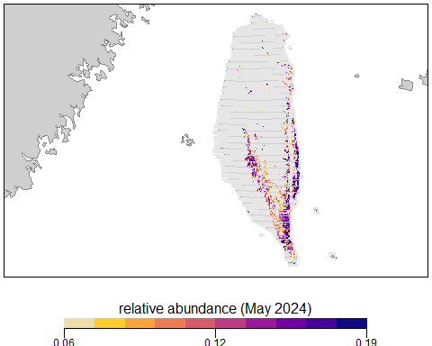
# Habitat associations ----
# ├ Predictor importance ----
# extract partial dependence from the encounter rate random forest
pi_er <- rf_er$variable.importance
pi_er <- data.frame(predictor = names(pi_er), importance = pi_er) |>
# scale so importances sum to 1
mutate(importance = importance / sum(importance)) |>
arrange(desc(importance))
# plot predictor importance for top 15 encounter rate predictors
ggplot(head(pi_er, 15)) +
aes(x = reorder(predictor, importance), y = importance) +
geom_col() +
geom_hline(yintercept = 0, linewidth = 2, colour = "#555555") +
scale_y_continuous(expand = c(0, 0)) +
coord_flip() +
labs(x = NULL,
y = "Predictor Importance",
title = "Predictor importance for encounter rate model") +
theme_minimal() +
theme(panel.grid = element_blank(),
panel.grid.major.x = element_line(colour = "#cccccc", linewidth = 0.5))
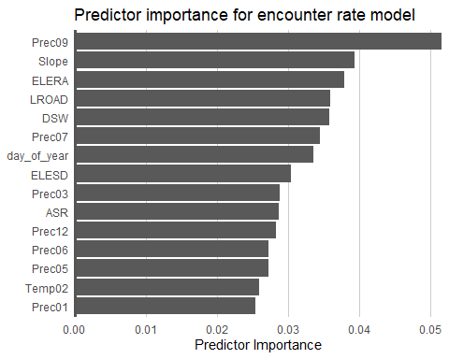
# ├ Partial dependence ----
# function to calculate partial dependence for a given predictor
calculate_pd <- function(predictor,
er_model, calibration_model,
data, x_res = 25, n = 1000) {
# create prediction grid using quantiles based on detections
detections <- data[data$species_observed, ]
x_grid <- quantile(detections[[predictor]],
probs = seq(from = 0, to = 1, length = x_res),
na.rm = TRUE)
# remove duplicates
x_grid <- x_grid[!duplicated(signif(x_grid, 8))]
x_grid <- unname(unique(x_grid))
grid <- data.frame(predictor = predictor, x = x_grid)
names(grid) <- c("predictor", predictor)
# subsample training data
n <- min(n, nrow(data))
data <- data[sample(seq.int(nrow(data)), size = n, replace = FALSE), ]
# drop focal predictor from data
data <- data[names(data) != predictor]
grid <- merge(grid, data, all = TRUE)
# estimate encounter rate
pred_er <- predict(er_model, data = grid, type = "response")
pred_er <- pred_er$predictions[, "TRUE"]
# apply calibration
pred_er_cal <- predict(calibration_model,
data.frame(pred = pred_er),
type = "response") |>
as.numeric()
# constrain to 0-1
pred_er_cal[pred_er_cal < 0] <- 0
pred_er_cal[pred_er_cal > 1] <- 1
# summarize
pd <- grid[, c("predictor", predictor)]
names(pd) <- c("predictor", "x")
pd$encounter_rate <- pred_er_cal
pd <- dplyr::group_by(pd, predictor, x)
pd <- dplyr::summarise(pd,
encounter_rate = mean(encounter_rate, na.rm = TRUE),
.groups = "drop")
return(pd)
}
# calculate partial dependence for elevation
pd_elevation <- calculate_pd("elevation_30m_median",
er_model = rf_er,
calibration_model = calibration_model,
data = checklists_train)
# plot partial dependence
ggplot(pd_elevation) +
aes(x = x, y = encounter_rate) +
geom_line() +
geom_point() +
labs(x = "Elevation [m]", y = "Encounter Rate")
## Warning: Removed 1 row containing missing values or values outside the scale range
## (`geom_line()`).
## Warning: Removed 1 row containing missing values or values outside the scale range
## (`geom_point()`).
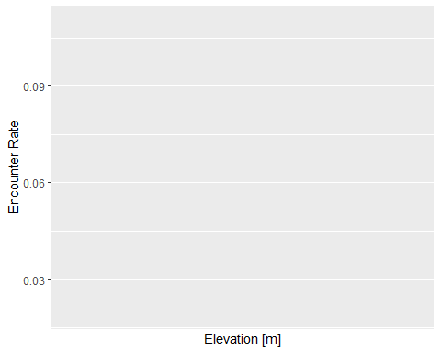
# calculate abundance partial dependence for each of the top 6 predictors
pd <- NULL
for (predictor in head(pi_er$predictor)) {
pd <- calculate_pd(predictor,
er_model = rf_er,
calibration_model = calibration_model,
data = checklists_train) |>
bind_rows(pd)
}
# plot partial dependence
ggplot(pd) +
aes(x = x, y = encounter_rate) +
geom_line() +
geom_point() +
facet_wrap(~ factor(predictor, levels = rev(unique(predictor))),
ncol = 2, scales = "free") +
labs(x = NULL, y = "Encouter Rate") +
theme_minimal() +
theme_minimal() +
theme(panel.grid = element_blank(),
axis.line = element_line(color = "grey60"),
axis.ticks = element_line(color = "grey60"))
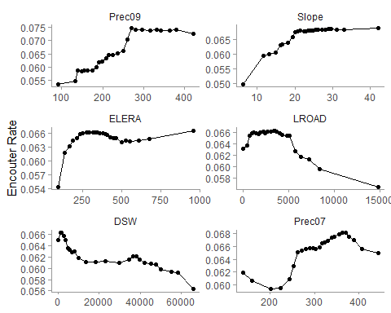
# EXERCISE: Produce the partial dependence plot for the checklist start time.
# How can this be used to help choose an optimal time of day for the
# standardized checklist that we predicted to prior to mapping?
pd_time <- calculate_pd("Aspect",
er_model = rf_er,
calibration_model = calibration_model,
data = checklists_train)
ggplot(pd_time) +
aes(x = x, y = encounter_rate) +
geom_line() +
geom_point() #+
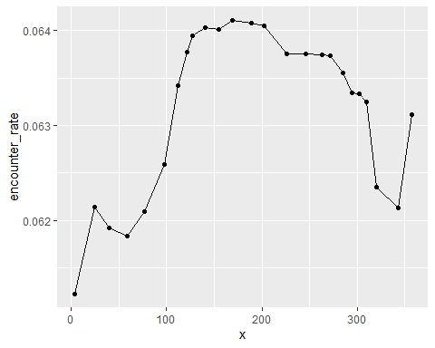
# scale_x_continuous(breaks = seq(-12, 12, by = 1)) +
# labs(x = "Checklist midpoint time [FO]",
# y = "Encounter Rate")

